DOCKER SAVE AND DOCKER LOAD :  
  
Assume a situation where you want to share the image with your client …so you want to create a tar file of the image and want to mail to the client and from the client location client can simply load that image …

PREPROD MACHINES STEPS :

Lets assume we have image named : 27sep

Now I want to share image with my client

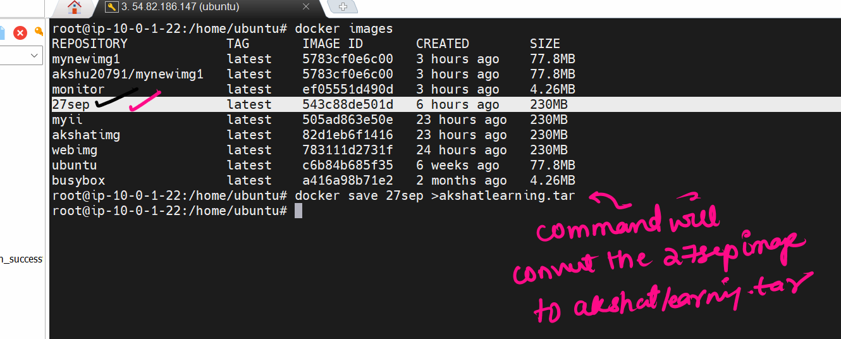docker save 27sep >akshatlearning.tar

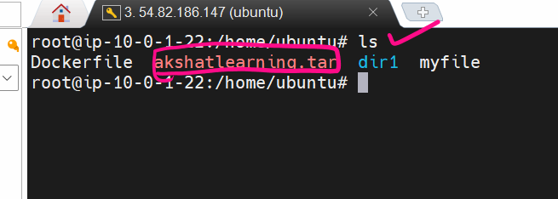

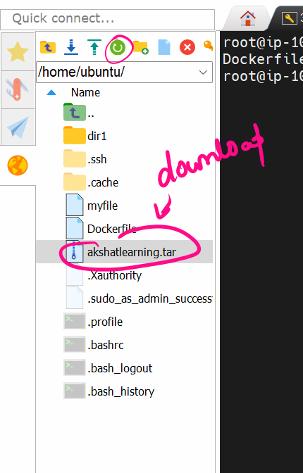



### NOW LETS GO TO THE PROD MACHINE (ANOTHER MACHINE) WE ASSUME THAT DOCKER IS ALREADY INSTALLED IN IT

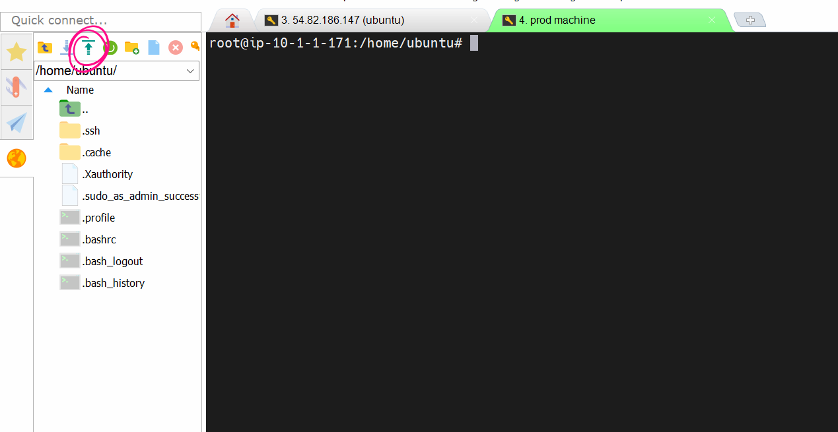

And upload the tar file

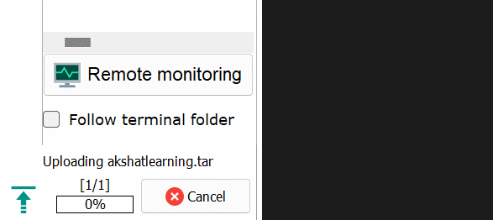

Wait for the tar file to be uploaded

After the upload is done

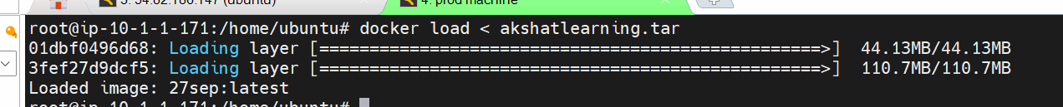

docker load < akshatlearning.tar

